English – Escape from Pompeii  We will read ‘Escape from Pompeii’ by Christina Balit. We will explore characters feelings, writing letters to of advice to help save them from the eruption of Mount Versuvius. Having collected powerful imagery from the text, we will then write a vivid description of the eruption to lead on to a final piece of writing – a newspaper report, including quotes from survivors in the town. | Maths – Multiplication & Division  We will be learning about factor pairs and how to multiply by 10 and 100. We will learn how to multiply and divide up to 3-digit numbers by a 1-digit number. We will do this for calculations that also need exchanges and also for calculations that leave remainders.  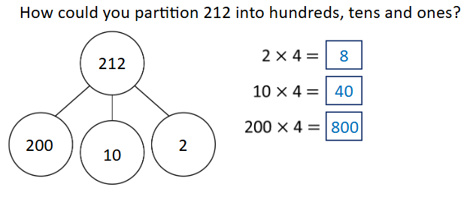 | Science- How are teeth, diet and digestion linked?  We will learn how animal’s teeth vary in appearance in relation to their function; how food is digested and how to care for our teeth. We will analyse patterns and form conclusions using our scientific knowledge.  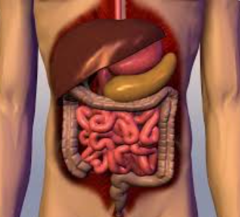 | Music  Northumberland Music Partnership will be continuing to teach your child in their selected instrument.  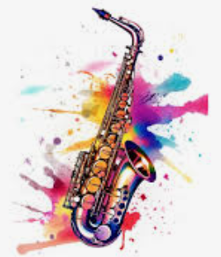
PSHE – What is positive health and well-being?  We will learn how to practise visualisation as a way to relax; consider our strengths and future career options, learn how to break down barriers to help us achieve a goal; identify a range of emotions and understand the term ‘mental health.’   | Geography - Why do people live near volcanoes?  We will be learning how the earth is constructed – this will then lead to discovering where on our planet that mountains and volcanoes are formed and why this is so. We will learn about earthquakes and the effects of them.  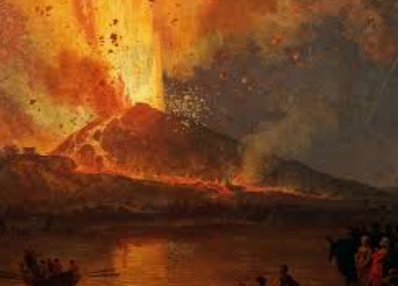 | RE – What does it mean to be a Hindu in Britain today?  We will be learning about how Hindus show their faith and the different ways in which Hinduism is practised across the world.  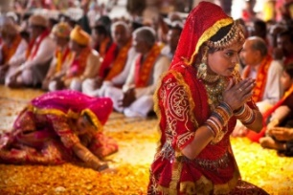 | Computing – How can we create repetition in games?  We will use Scratch to program animations which can be looped infinitely or count-controlled. We will finish the unit by designing a project – our own game!  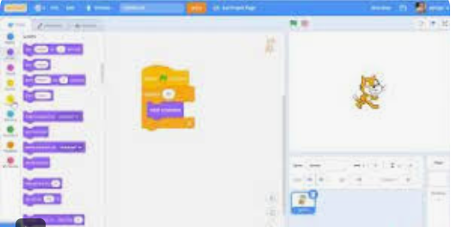
Art – Can you experiment with the processes used in prehistoric art?  We will learn about pre-historic art, create our own paints using natural pigments and try a range of painting techniques.  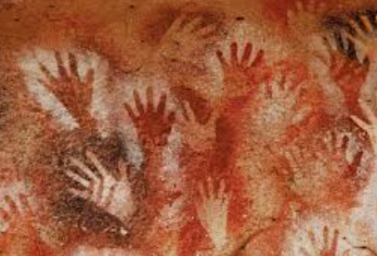 | PE – Target games  This half term we will be focusing on learning the skills needed for target games.   | French – En Classe  We will learn the names and determiners for different classroom objects and will be able to say what we do and don’t have in our pencil cases.  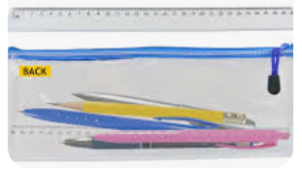 | Enrichment opportunities  Art Club  PE Club – Basketball  Partnership Rugby at Wark

